# **Digital Forensics Investigation Report: Clampet Case**

**Investigator:** Ethan Spade  
 **Case File:** Clampet.E01 Analysis  
 **Date:** 12/12/2025  
 **Tools Used:** Autopsy, Registry Explorer, Hex Workshop, Snip Tool, John the Ripper

## **1. Executive Summary**

This report documents the forensic examination of a disk image provided labeled Clampet.E01. This report represents the determination of user activity, system configuration, and any potential evidence supporting indications of suspicious or illicit behavior. The image was mounted and found to contain a Microsoft Windows XP Service Pack 2 operating system. One primary user account was identified as “jethro.” The system would appear to have been used in an active state for a considerable period of time, with numerous logins, web, email use, and created files attributed to this account.

The goals of the examination were to reconstruct the user's actions and locate relevant artifacts that might indicate criminal behavior. Indeed, some of the striking patterns found were money-laundering searches, instructional documents in possession about specific illegal activities, detected recoverable deleted files referring to criminal debriefing, and removable media use. These findings, when considered together, indicate intentional research, documentation, and hidin -implicating suspicious and perhaps criminal activity rather than incidental or benign use.

## **2. Scope of Investigation**

The primary objectives of this analysis were to:

● Identify the main Windows user account and related login activity.  
 ● Examine system configuration details including OS, time zone, and hardware artifacts.  
 ● Reconstruct browser history, downloaded files, and search behavior.  
 ● Review email activity, attachments, and communication patterns.  
 ● Investigate installed software and recent launch activity.  
 ● Identify deleted, hidden, or suspicious files.  
 ● Correlate all findings into a coherent behavioral profile.

All evidence was examined using industry standard forensic tools to ensure integrity and accuracy.

## **3. Hash Verification**

The integrity of the evidence file was verified prior to analysis. The MD5 hash of **Clampet.E01** was compared against the provided reference hash.

* **Clampet.E01.txt:** a9fb9bb2f697b25676b92153b60f1b7b
* **FTK Imager:** a9fb9bb2f697b25676b92153b60f1b7b
* **MD5 Match Status:** Match  
  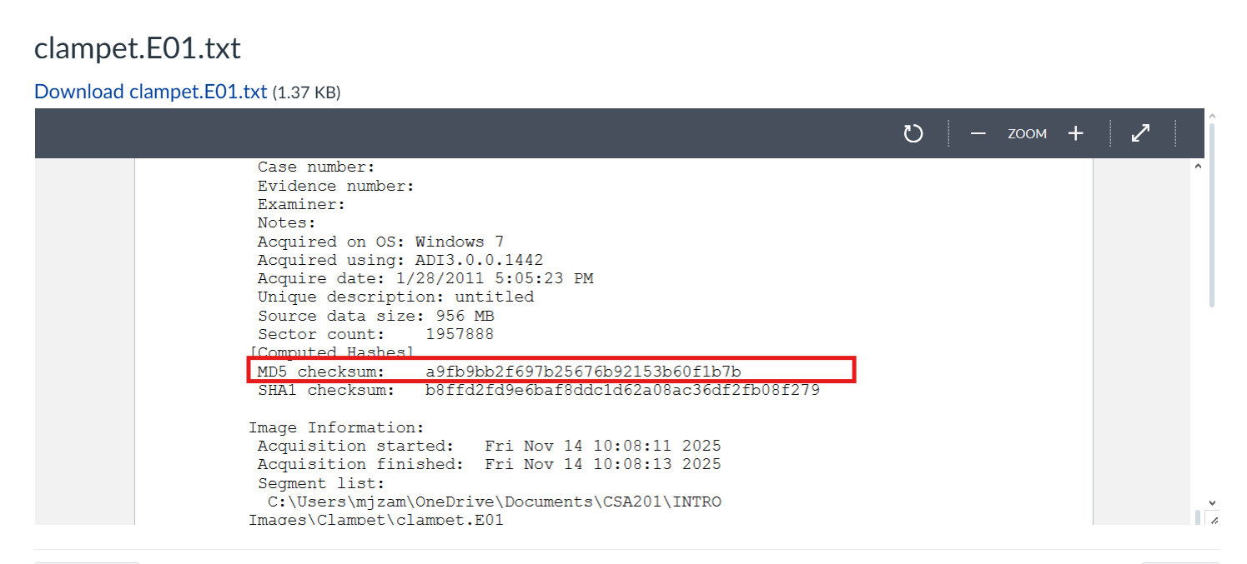

Figure 1 Shows the provided MD5 hash

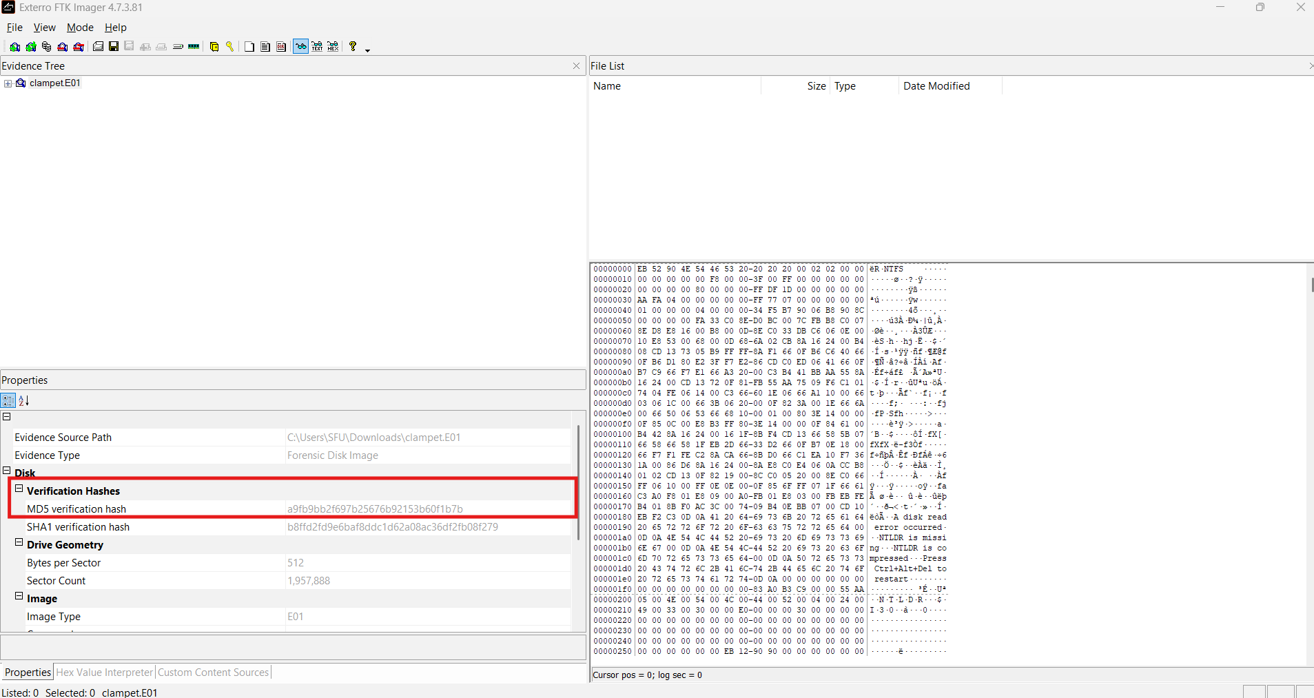

Figure 2 MD5 hash extracted via FTK Imager

## **Essential Flags & Findings**

### **1. User Account Discovery: Main Windows User**

* Primary User Name: jethro
* Number of logins: 52
* Password policy: Password does not expire  
  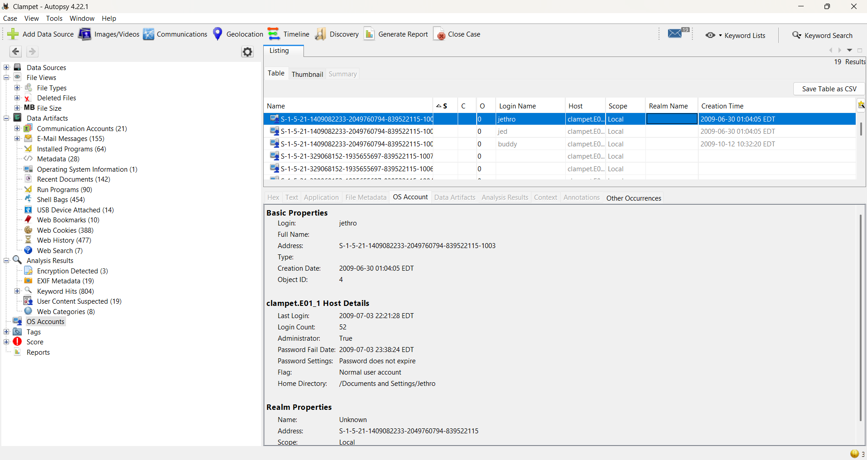

Figure 3 Screenshot of main user account

### **2. Last Login Time**

* Most recent login: 2009-07-03 22:21:28 EDT  
  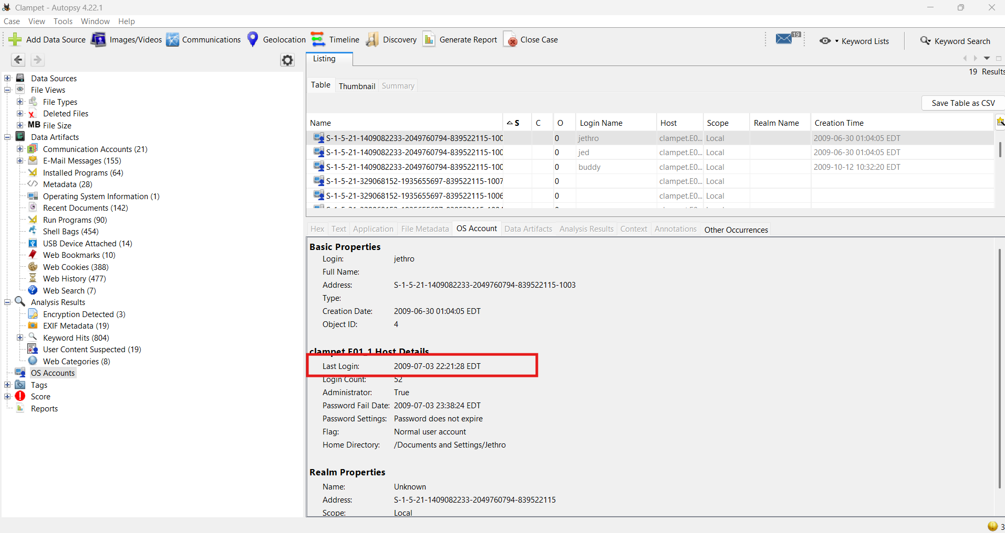

Figure 4 Last login timestamp

### **3. Operating System Version**

* OS Installed: Microsoft Windows XP Service Pack 2

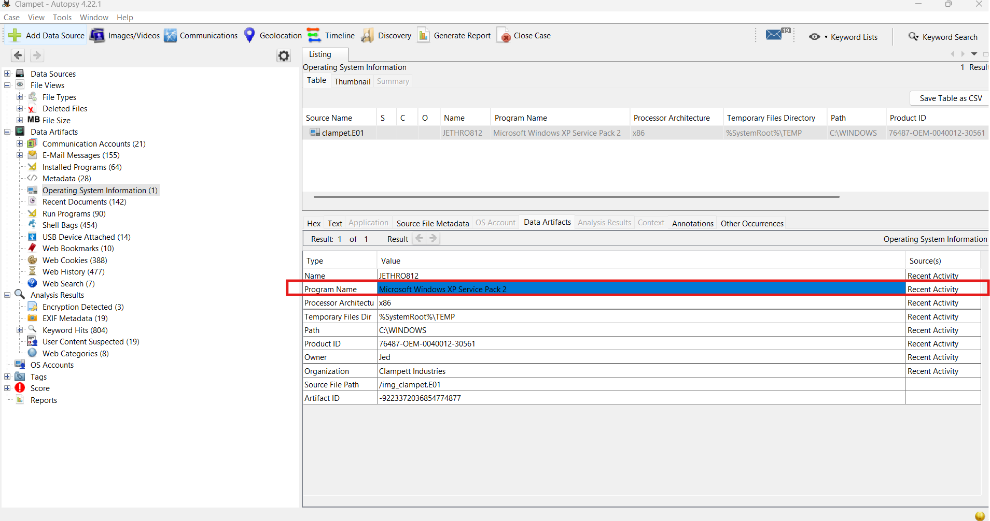

Figure 5: Operating system screenshot

### **4. Time Zone Settings**

* Time Zone:America/New_York (EST)

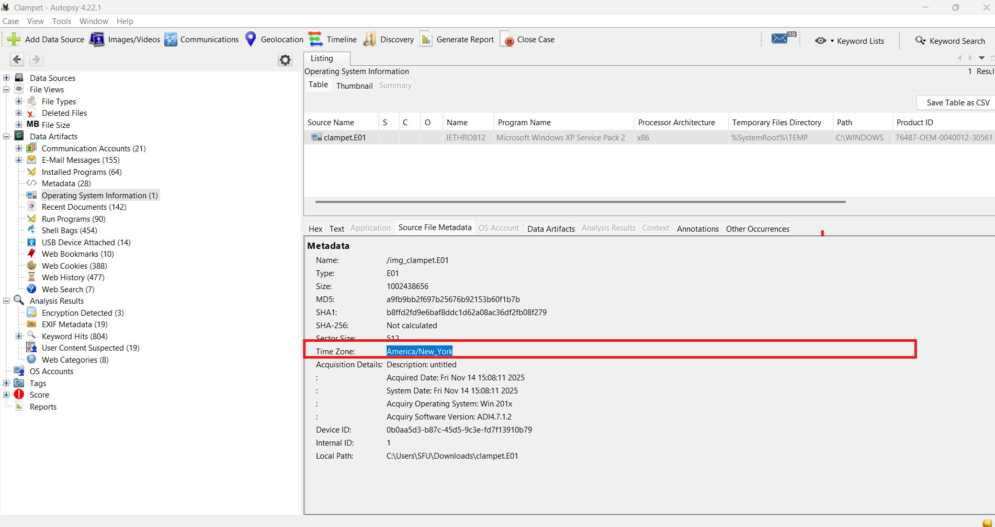

Figure 6 Time zone screenshot

### **5. USB Device History**

Provide:

* Make: SanDisk Corp.
* Model: SDCZ2 Cruzer Mini Flash Drive (thin)
* Serial: 20043514910C54A0CBEB
* This indicates the use of removable storage, which may have been employed for data transfer or concealment.   
  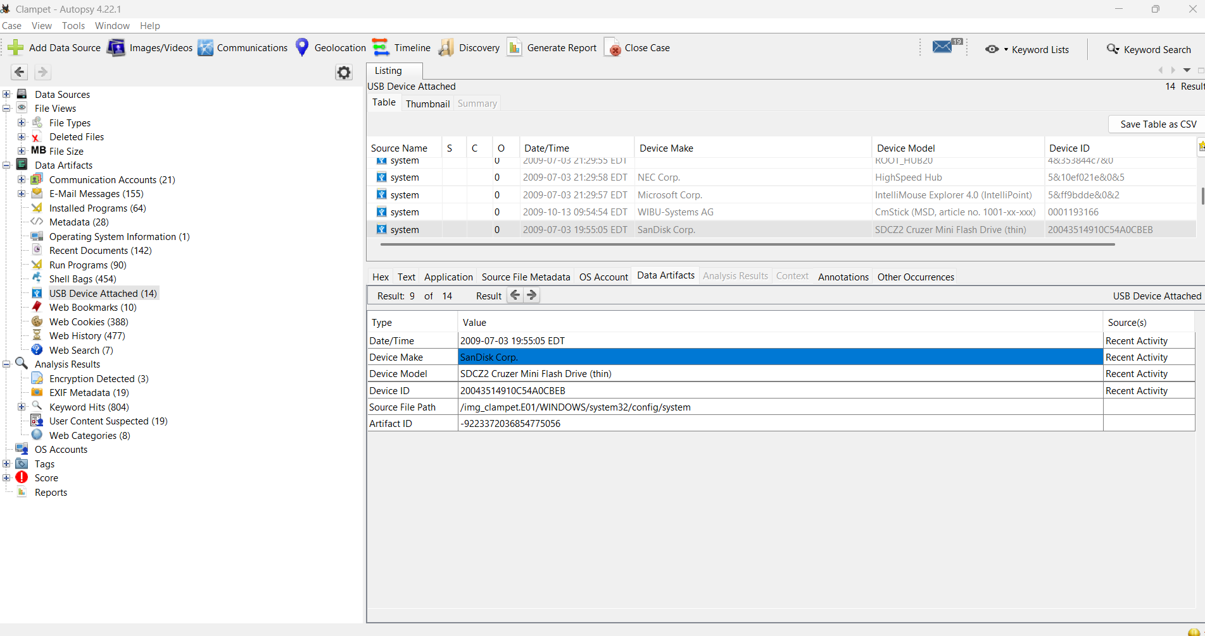

Figure 7 USB device artifact

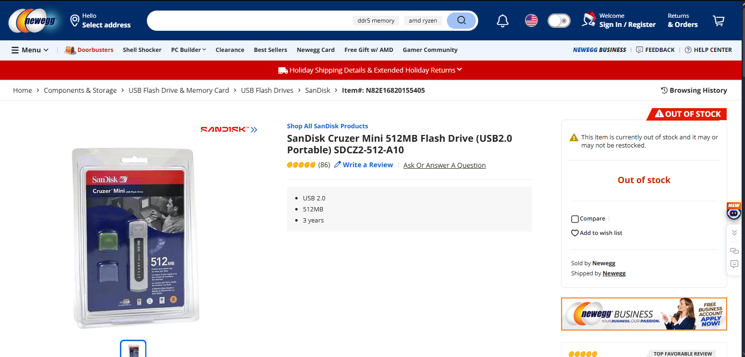

Figure 8 USB device artifact store page

### **6. Browser History: Websites Visited**

List at least three notable visited websites:

1. https://en.wikipedia.org/wiki/The_Beverly_Hillbillies
2. http://www.ehow.com/how_4424321_feed-new-born-kittens.html?ref=fuel&utm_source=yahoo&utm_medium=ssp&utm_campaign=yssp_art
3. https://www.microsoft.com/isapi/redir.dll?prd=windows&sbp=mediaplayer&plcid=&pver=6.1&os=&over=&olcid=&clcid=&ar=Media&sba=RadioBar&o1=&o2=&o3=

While some sites appear benign, the variety of instructional and reference based browsing suggests purposeful information gathering. While the site EHow does exist, the exact article referenced does not. As for the final link the site itself fully does not exist.

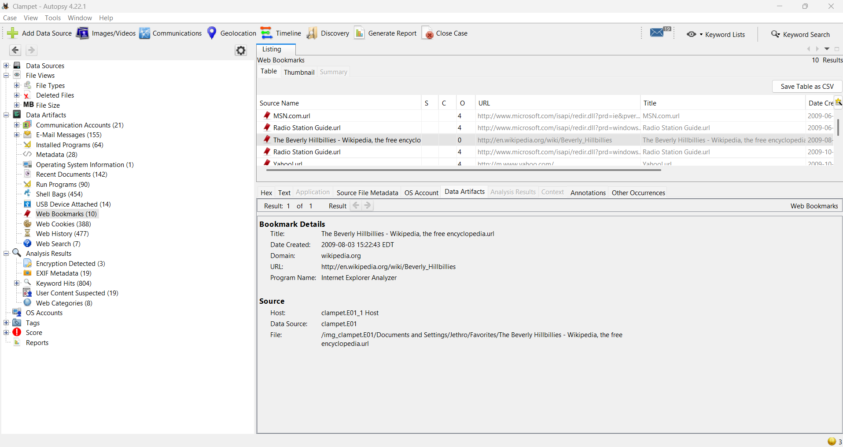

Figure 9 https://en.wikipedia.org/wiki/The_Beverly_Hillbillies in autopsy

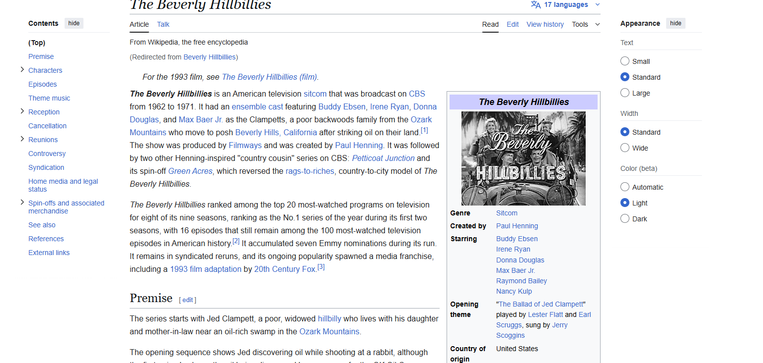

Figure 10 https://en.wikipedia.org/wiki/The_Beverly_Hillbillies

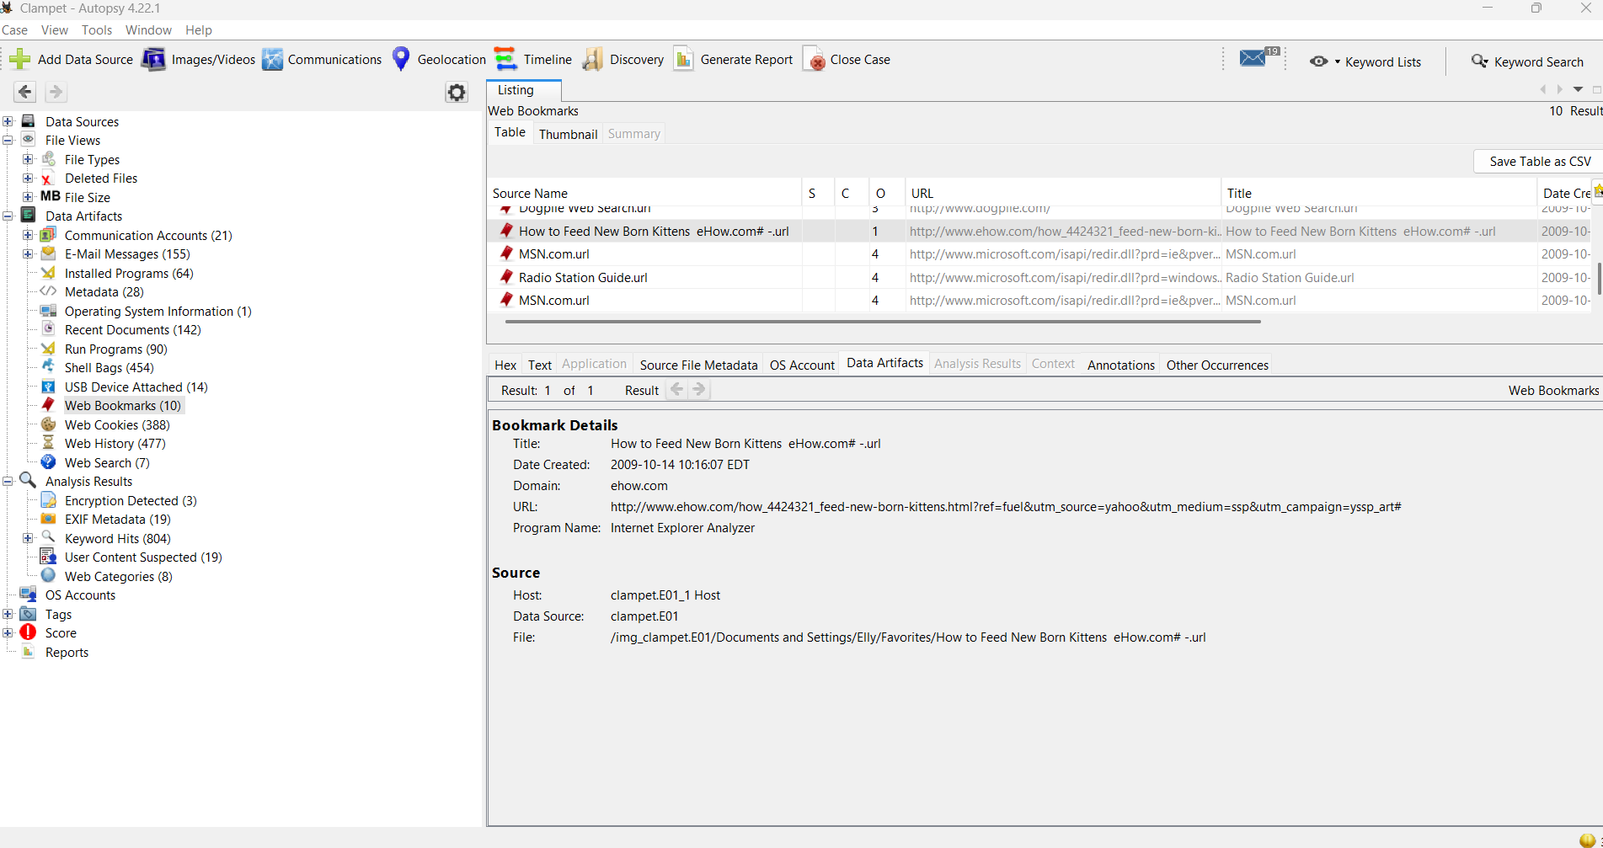

Figure 11 http://www.ehow.com/how_4424321_feed-new-born-kittens.html?ref=fuel&utm_source=yahoo&utm_medium=ssp&utm_campaign=yssp_art in autopsy

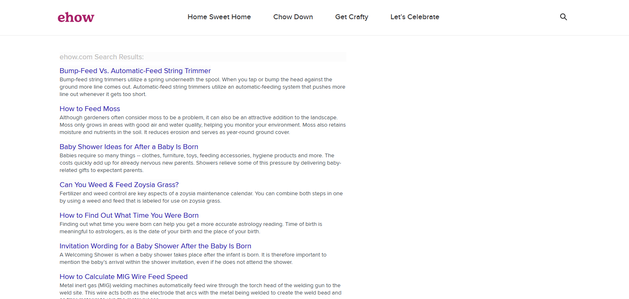

Figure 12 http://www.ehow.com/how_4424321_feed-new-born-kittens.html?ref=fuel&utm_source=yahoo&utm_medium=ssp&utm_campaign=yssp_art

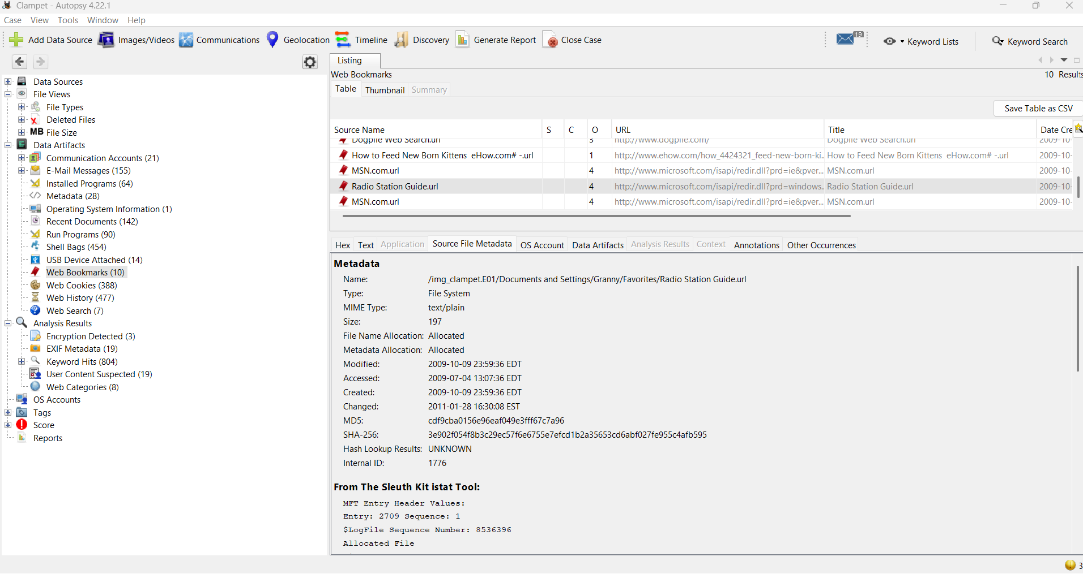

Figure 13 https://www.microsoft.com/isapi/redir.dll?prd=windows&sbp=mediaplayer&plcid=&pver=6.1&os=&over=&olcid=&clcid=&ar=Media&sba=RadioBar&o1=&o2=&o3= in autopsy

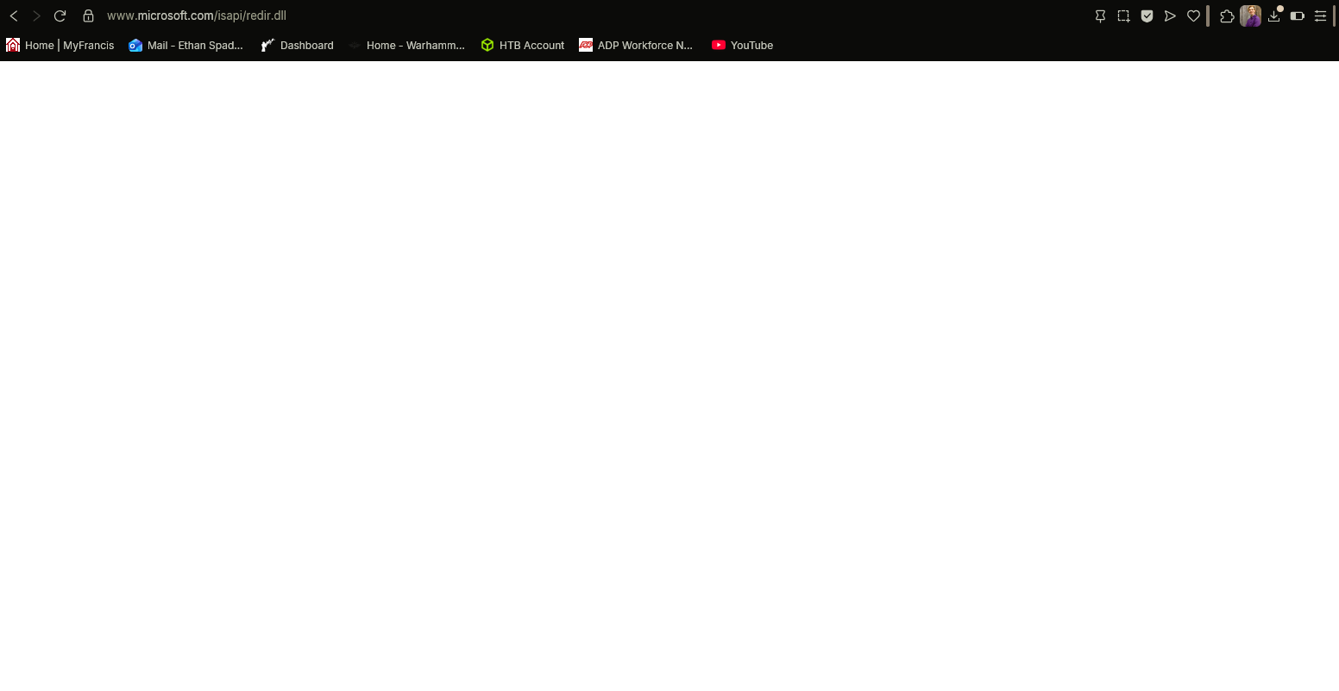

Figure 14 https://www.microsoft.com/isapi/redir.dll?prd=windows&sbp=mediaplayer&plcid=&pver=6.1&os=&over=&olcid=&clcid=&ar=Media&sba=RadioBar&o1=&o2=&o3=

### **7. Suspicious Search Queries**

List suspicious/incriminating searches:

* Money laundering images
* First date etiquette
* Proper Feeding Kittens

The presence of searches related to money laundering is particularly concerning when correlated with file artifacts found elsewhere on the system.

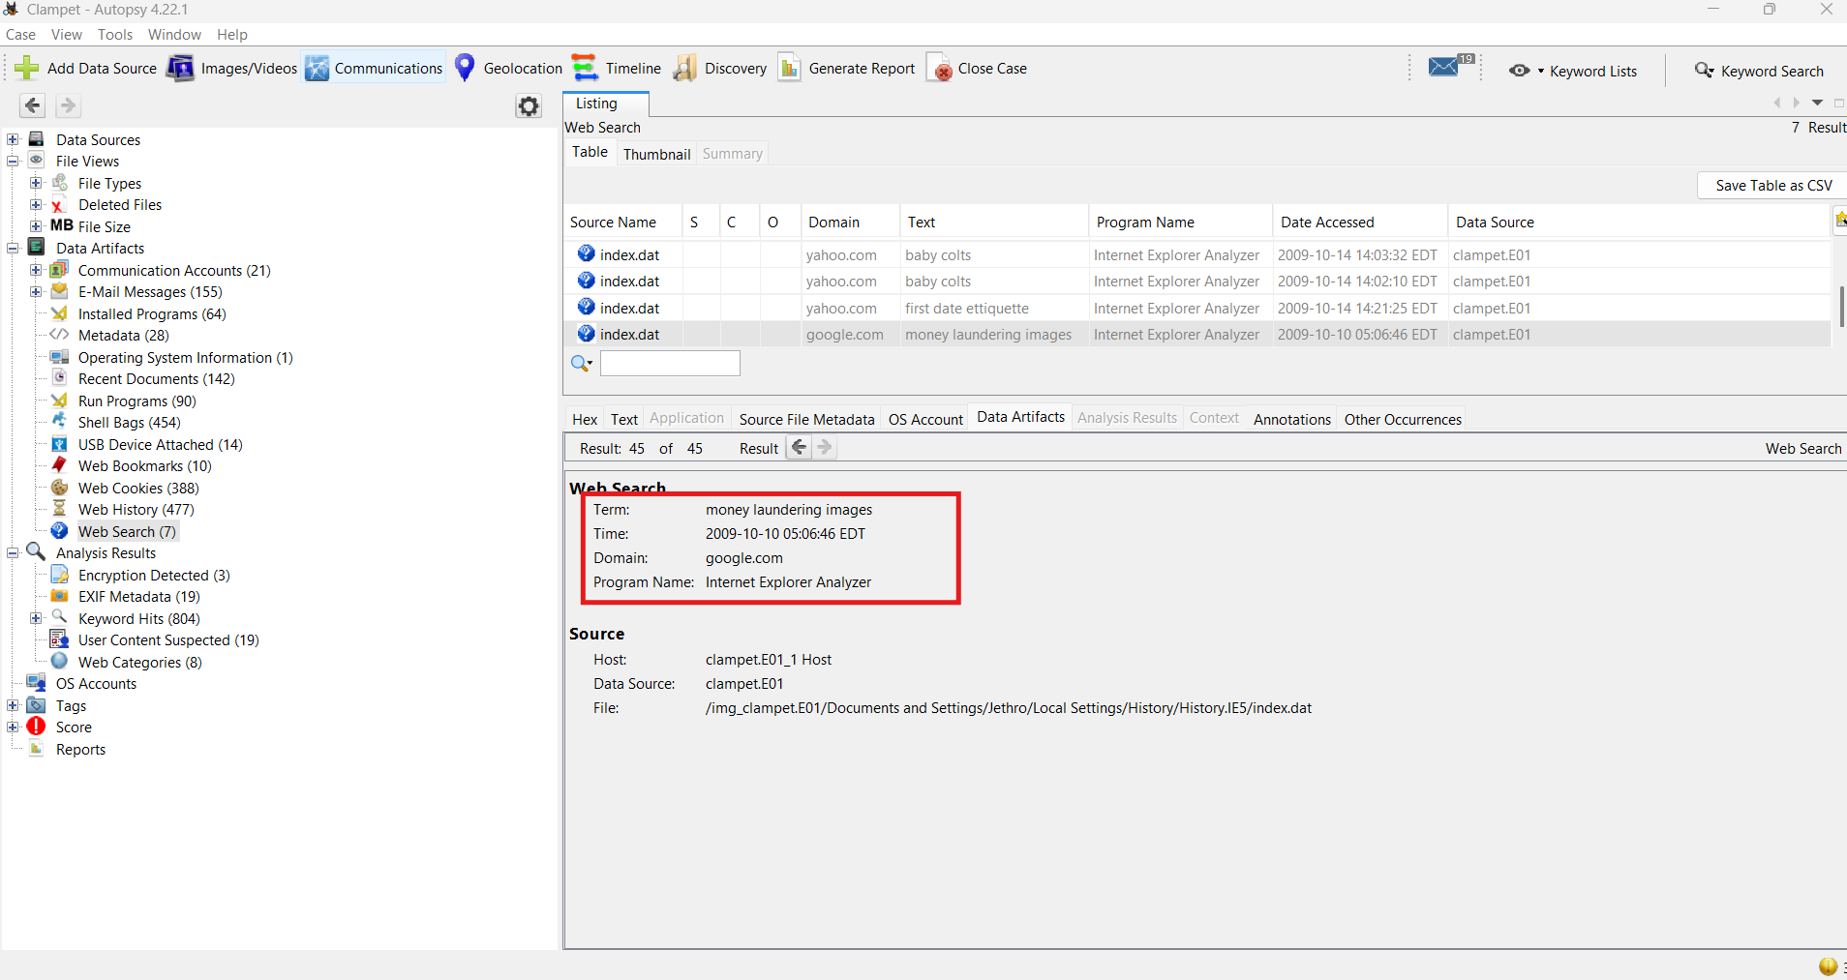

Figure 15 Money laundering images

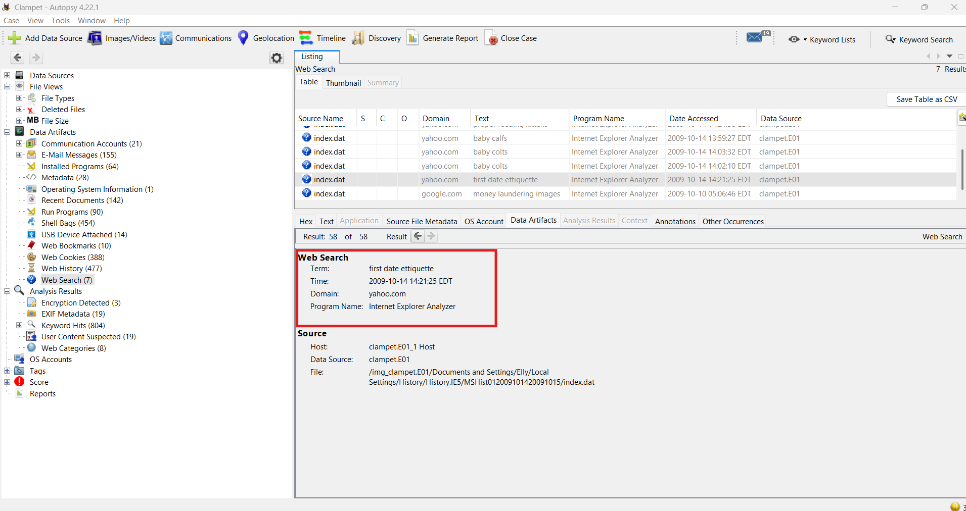

Figure 16 First date etiquette

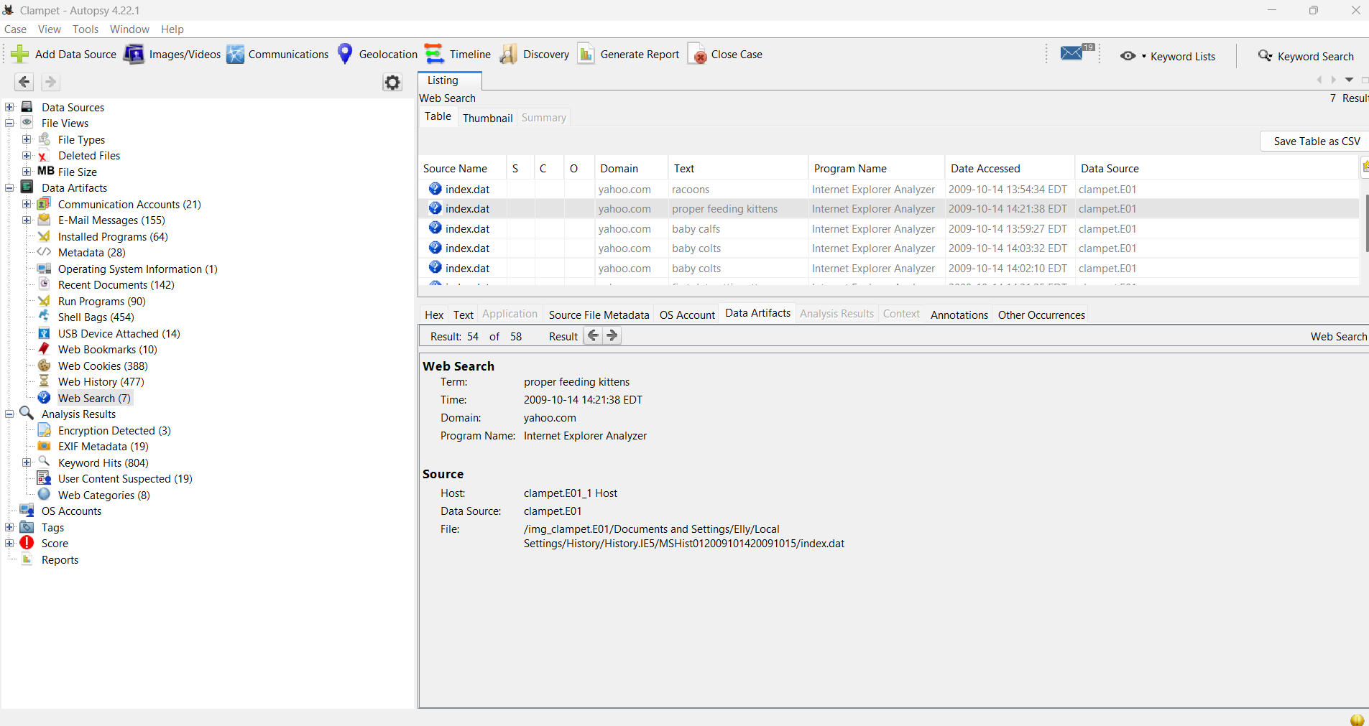

Figure 17 Proper Feeding Kittens

### **8. Email Attachments: Sent or Received**

Describe at least one email with an attachment found in the system.  
 Attachment details: Document file containing instructional material related to a “love potion” found elsewhere.

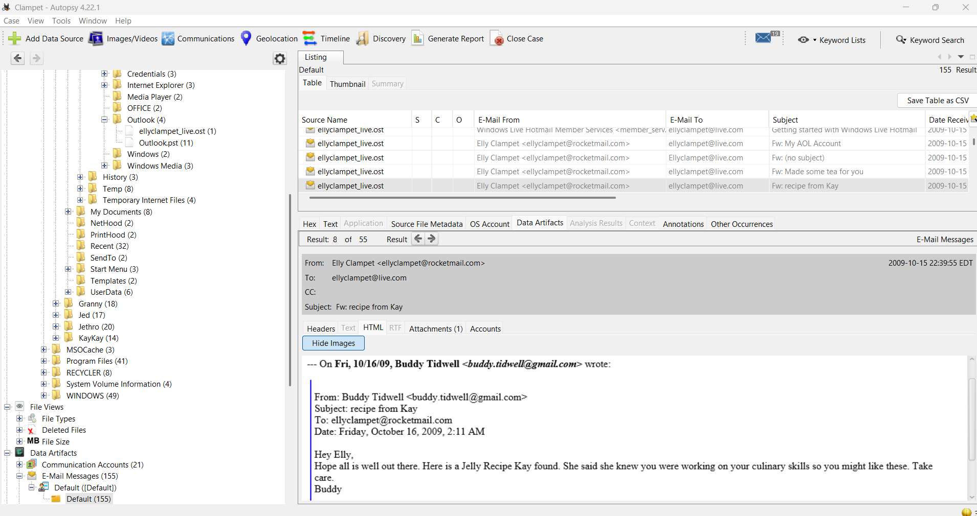

Figure 18 email including attachment

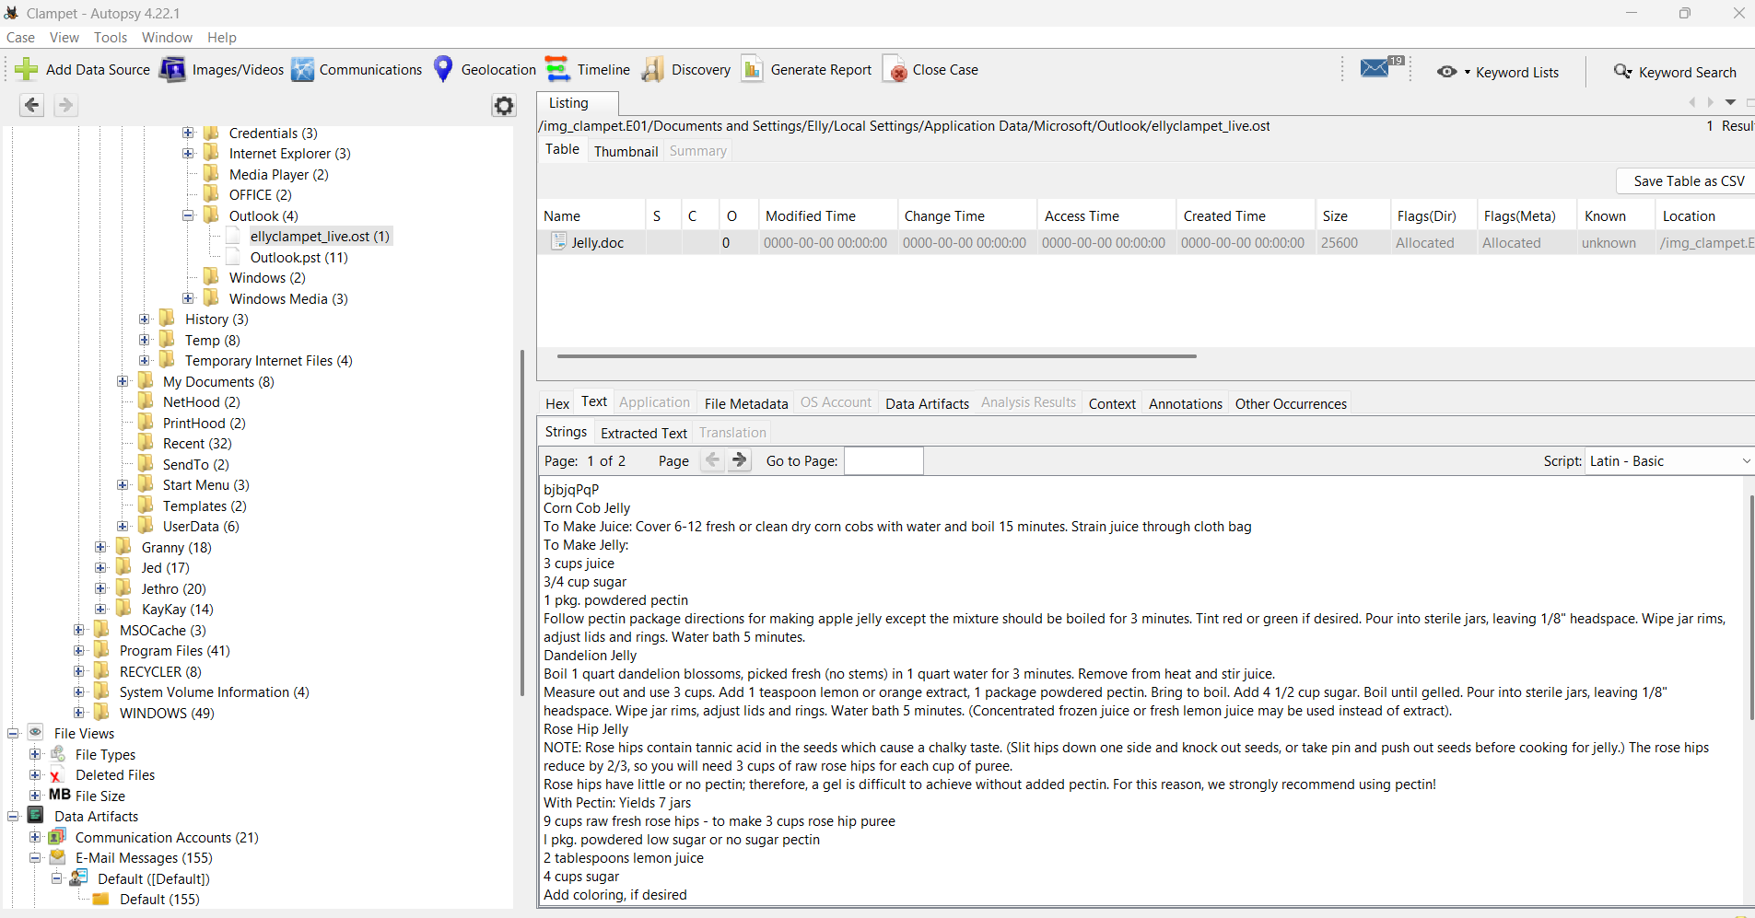

Figure 19 attachment from above email

### **9. Email Artifacts: Addresses Used**

List at least one email address found on the device:

* Ellyclampet@rocketmail.com

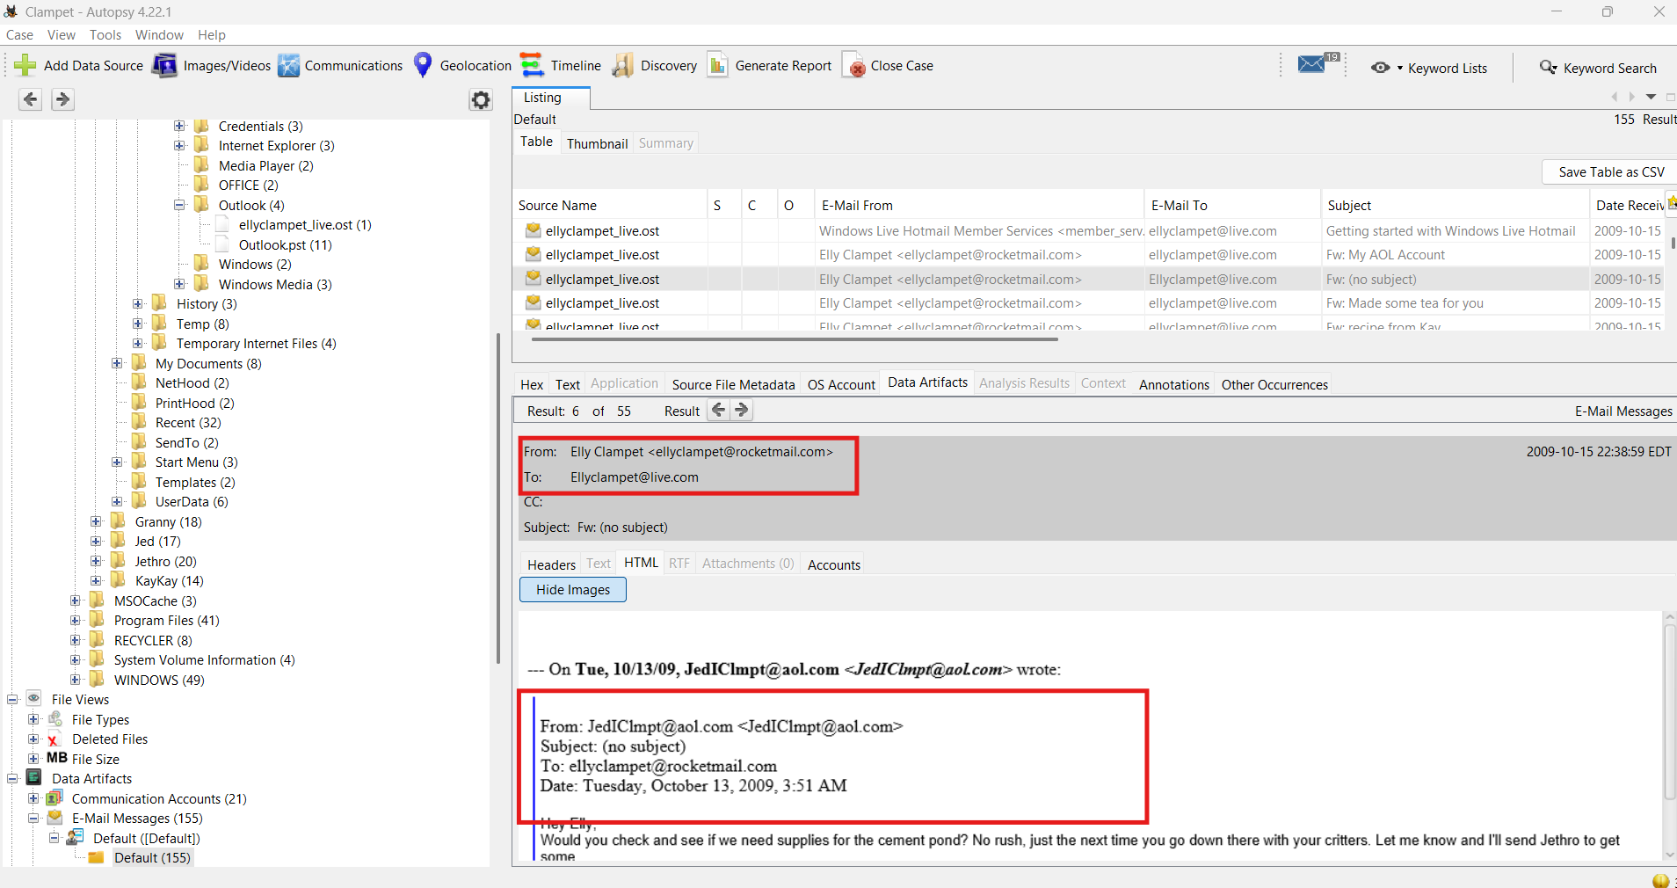

Figure 20 Email artifact screenshot

### **10. Pictures: Meaningful Images Located**

List three notable images and why they matter:

1. Moonshine Machine
2. Moonshine Shack
3. Bottle and Balloon
4. Web search of how to make moonshine

These images, combined with associated web searches on how to produce moonshine, suggest research into illegal alcohol production.

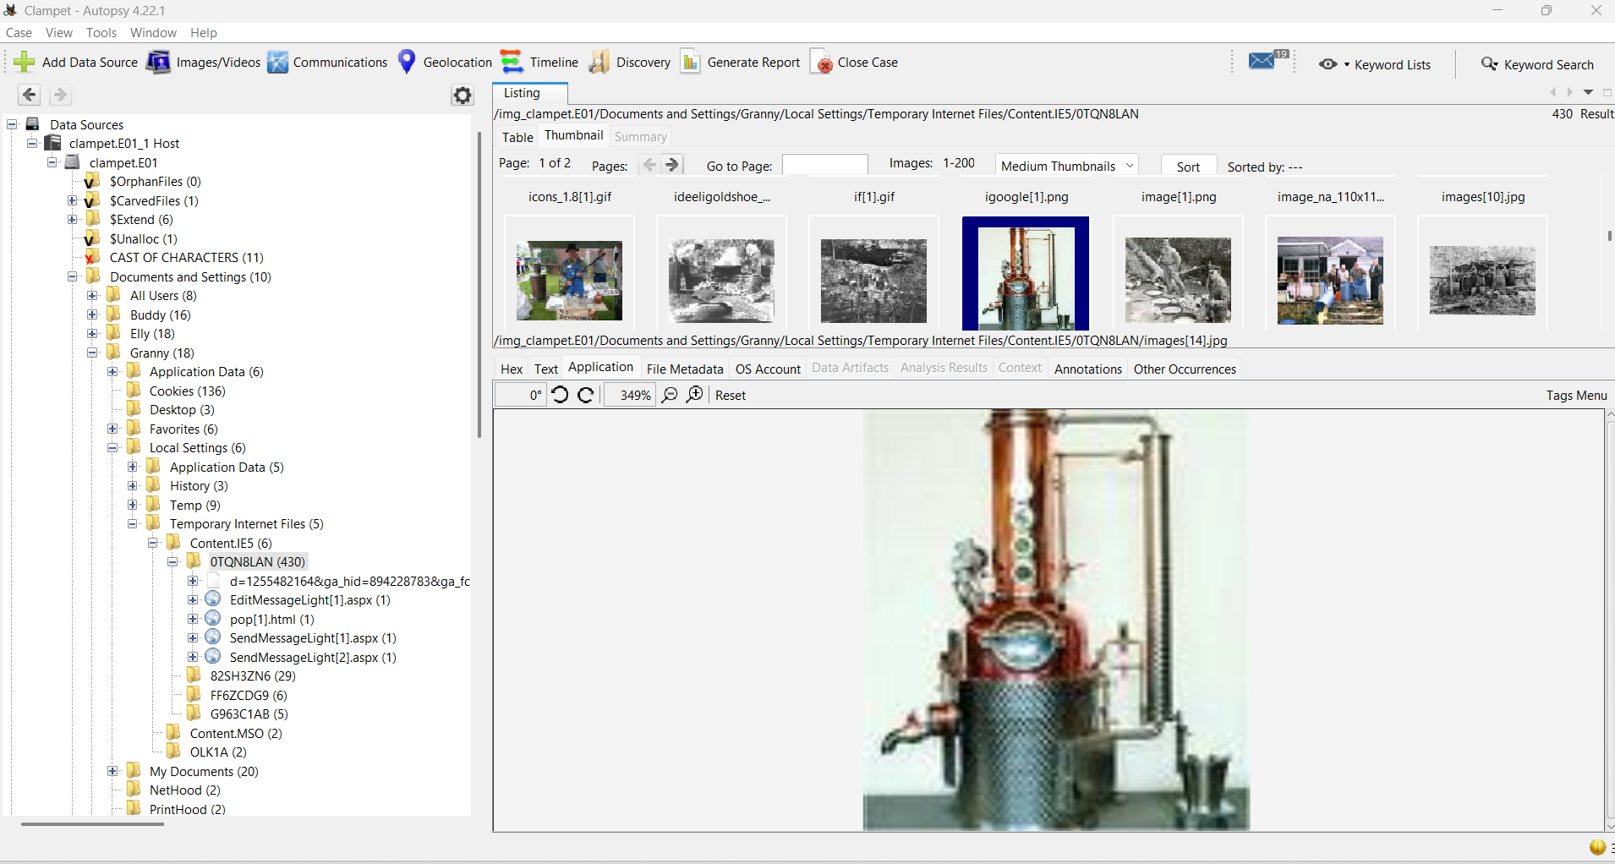

Figure 21 moonshine making machine

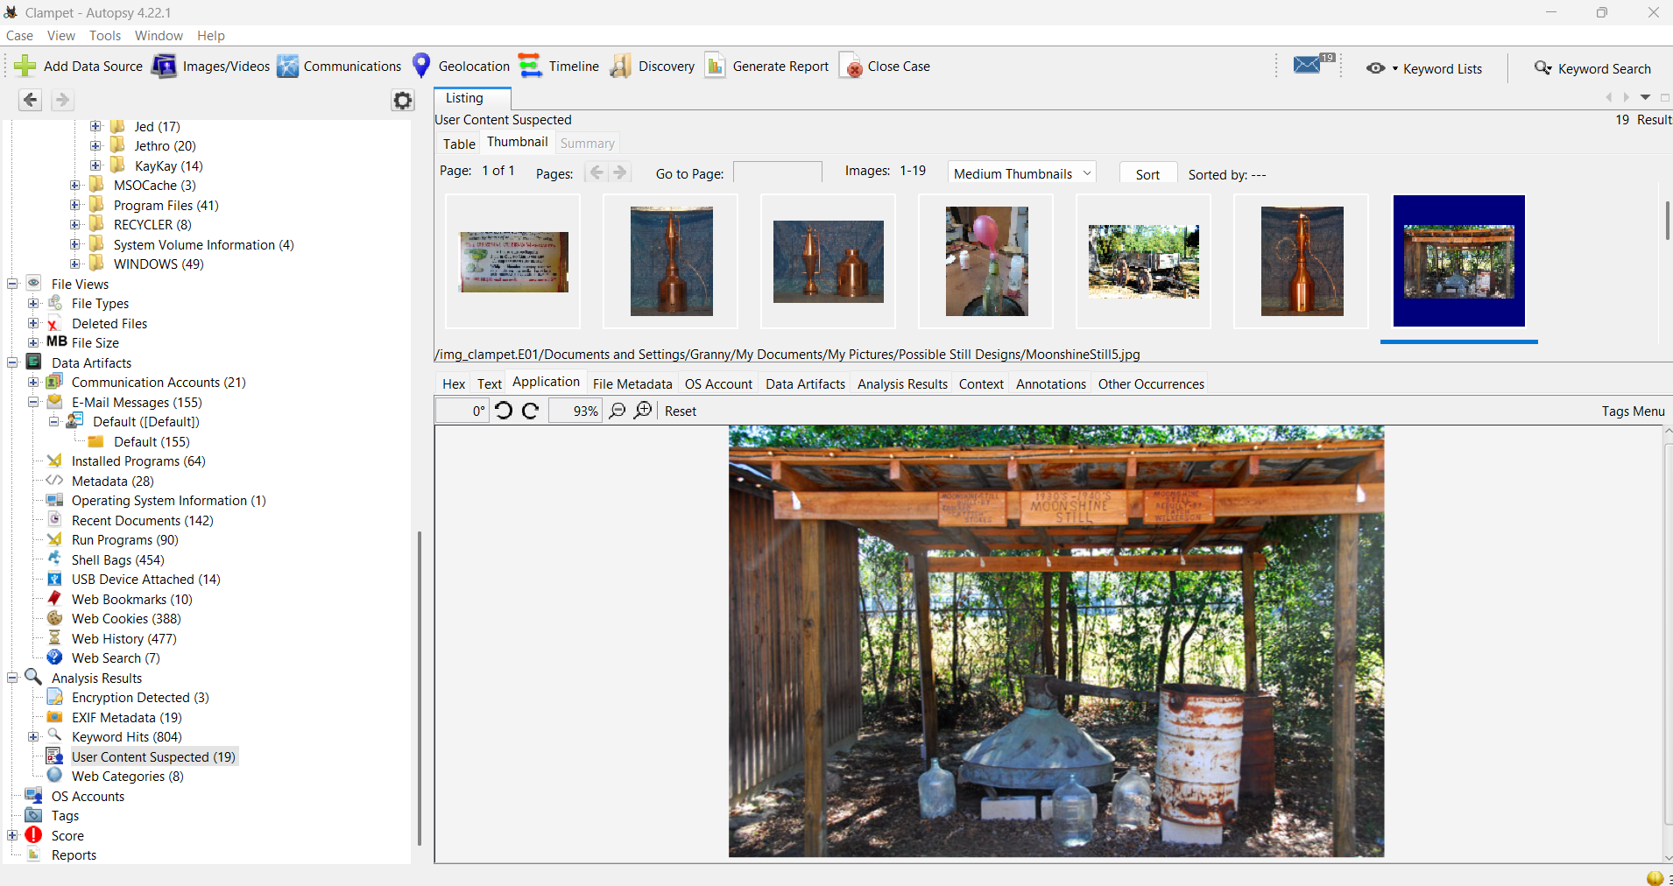

Figure 22 moonshine making hardaware and shack

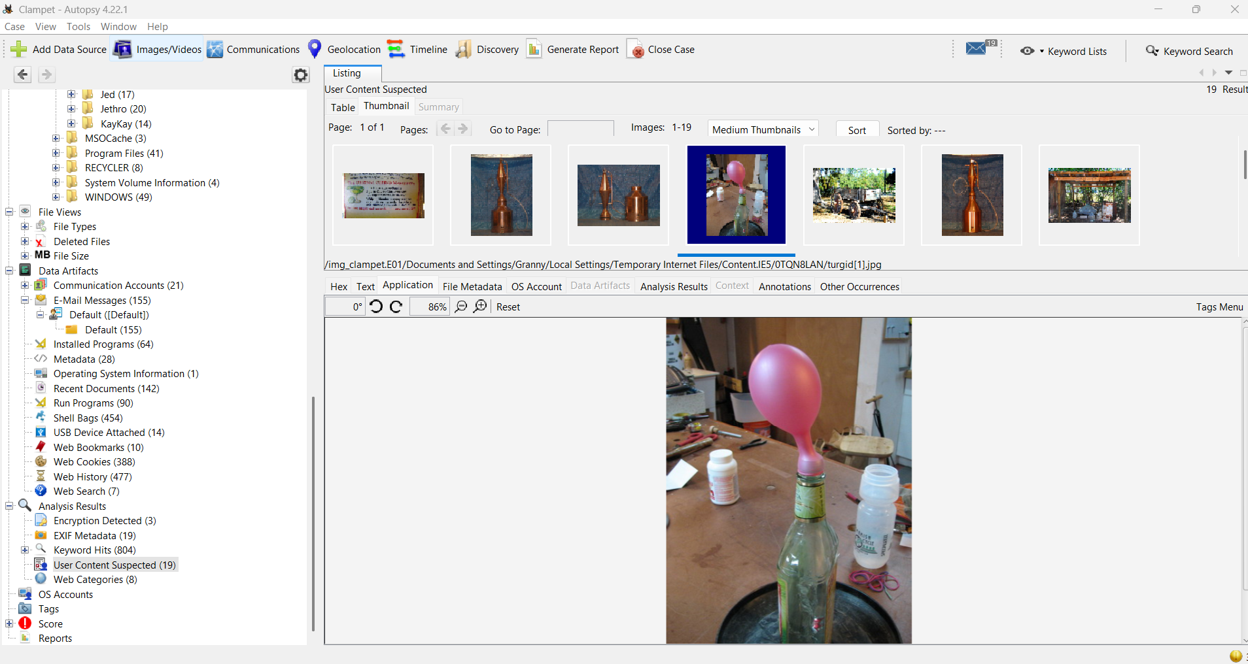

Figure 23 probably something to do with moonshine

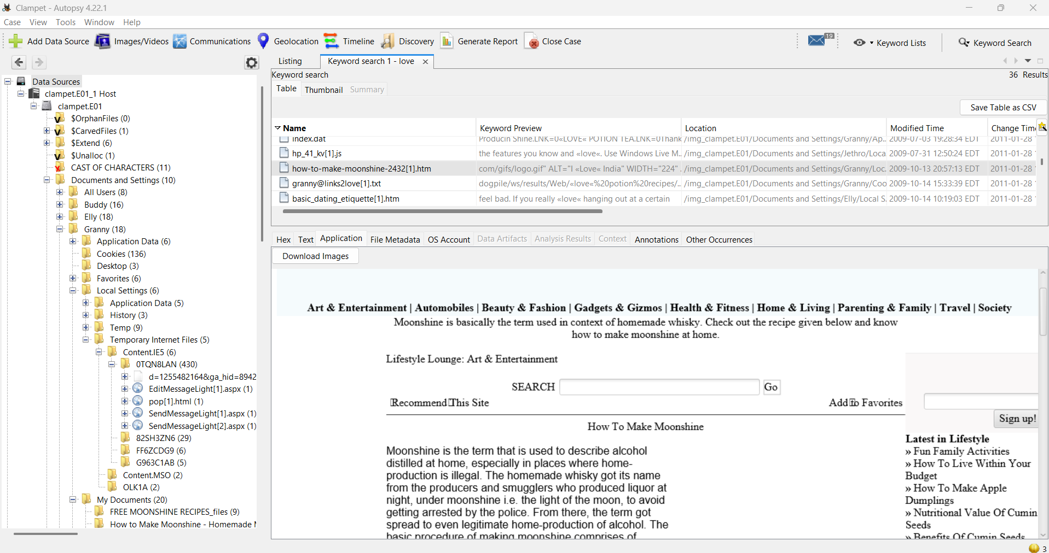

Figure 24 a literal guide on how to make moonshine

### **11. Software Installed**

List at least three installed programs:

* DirectDrawEX
* DirectAnimate
* Scheduling agent

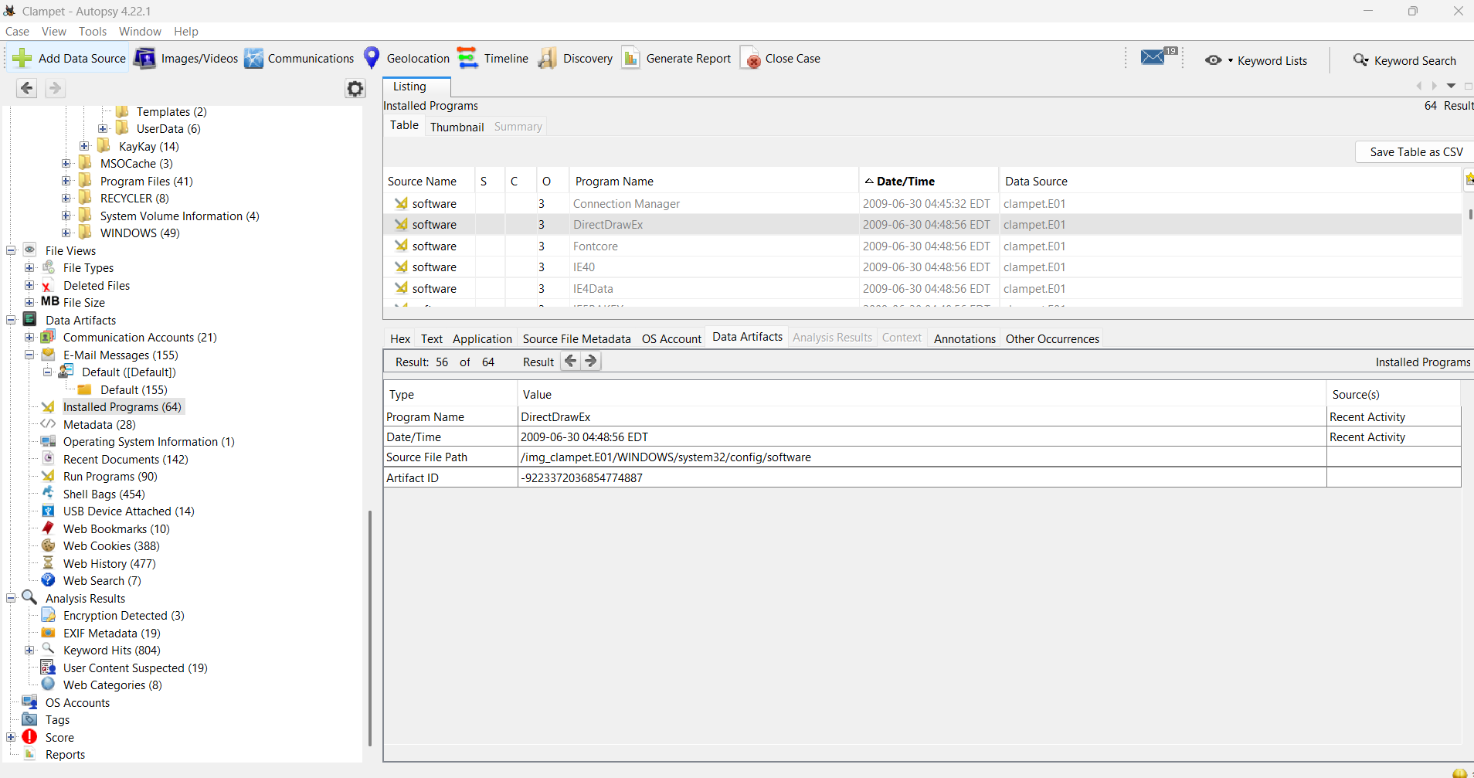

Figure 25 DirectdrawEX

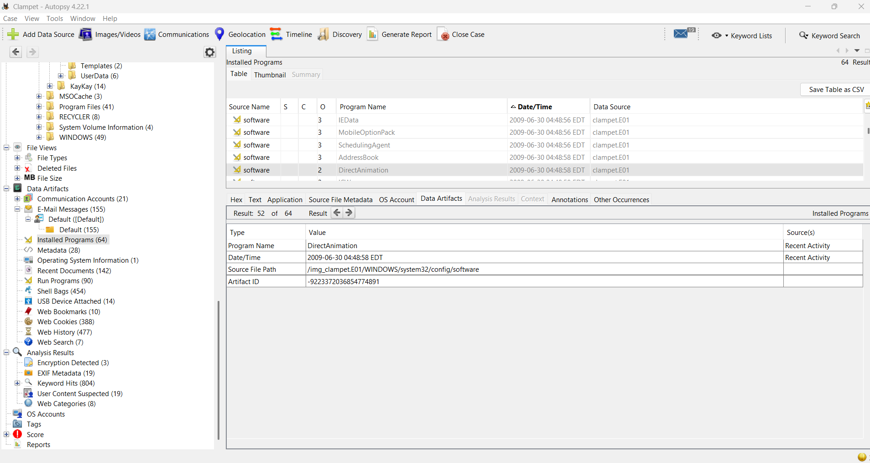

Figure 26 Directanimate

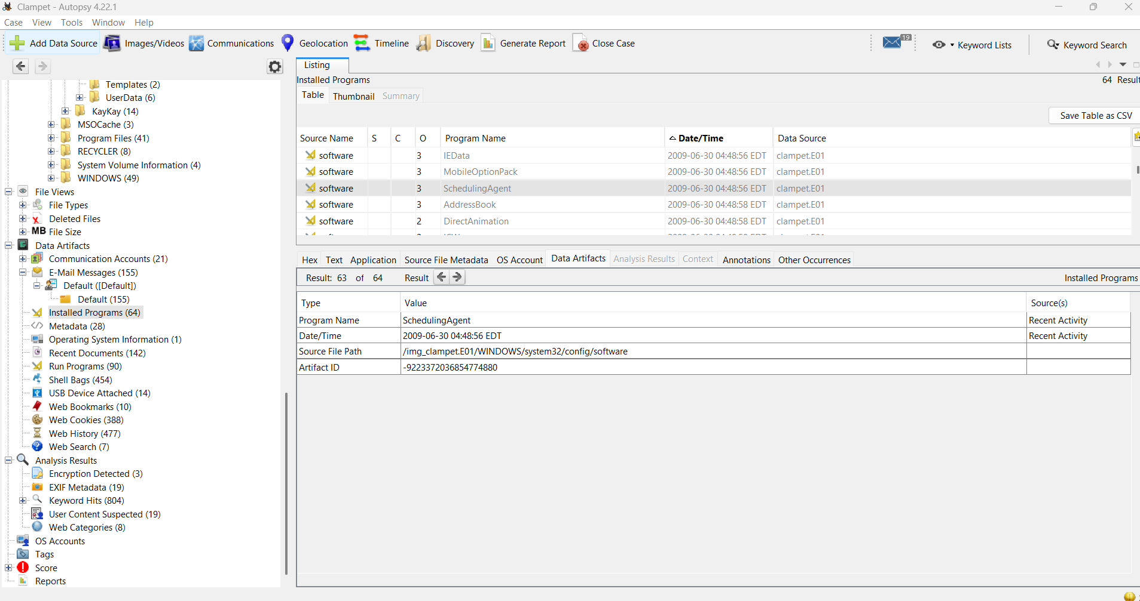

Figure 27Schedulingagent

### **12. Recently Launched Suspicious Software**

Identify any concerning applications and last run time:

* Program Name: Money Laundering Basics.doc
* Why it’s suspicious:Jeez I wonder (It’s literal instructions on how to launder money)
* Last Run Time: 2011-01-28 16:52:16 EST  
  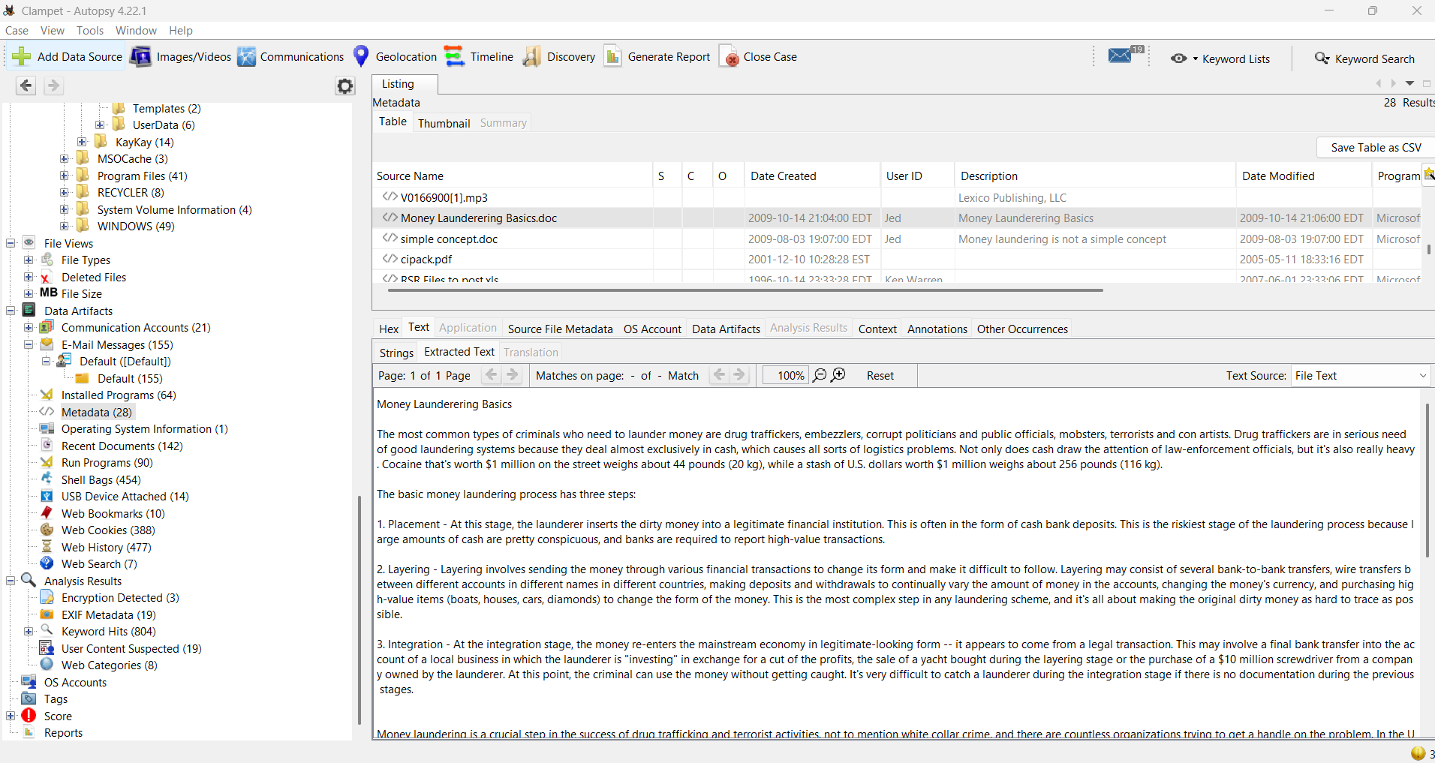

Figure 28 Suspicious application Screenshot

### **13. Deleted Files**

Provide details on at least one recovered deleted file:

* File name: cipack.pdf
* Location: /img_clampet.E01/Documents and Settings/Jethro/Delete This/cipack.pdf
* Reason of Interest: The file appears to be a debriefing or instructional document outlining criminal activities. Its location within a folder explicitly labeled “Delete This” suggests an attempt to conceal evidence.  
  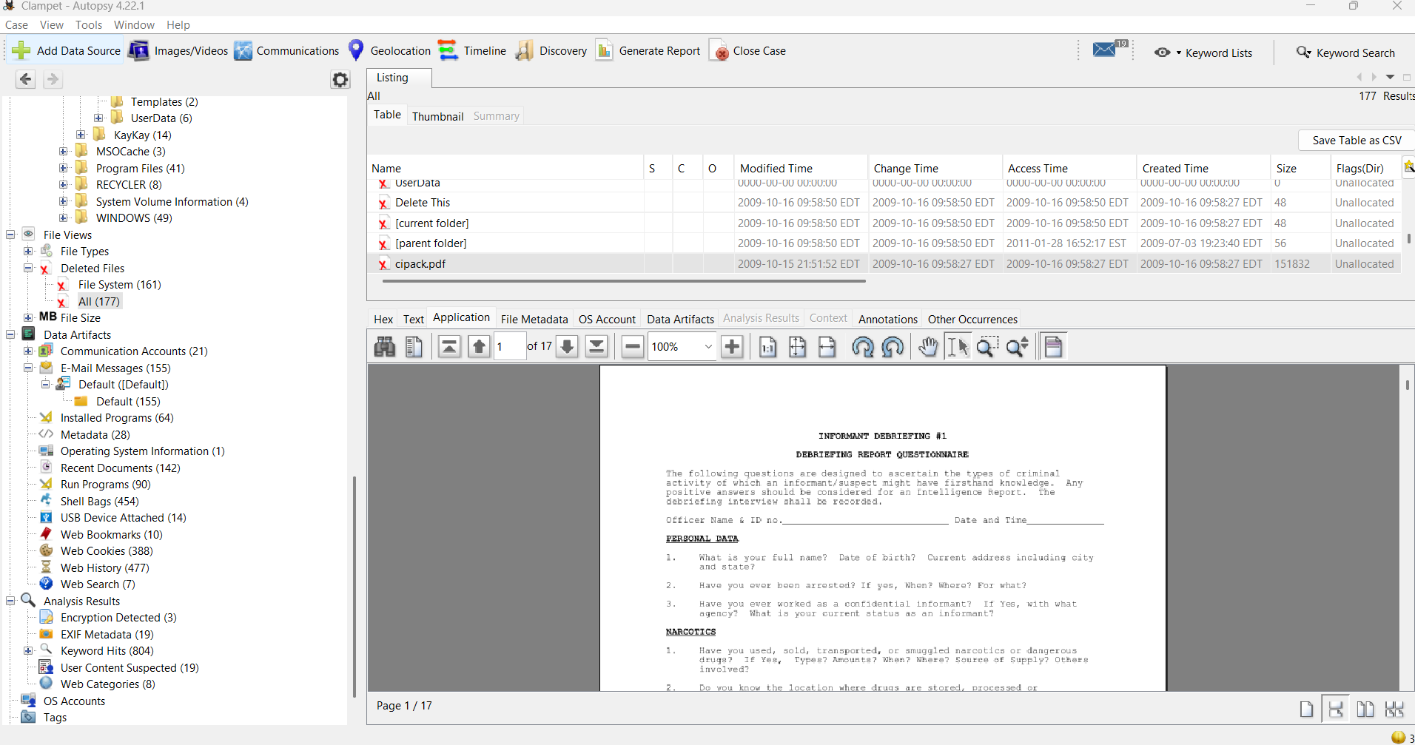

Figure 29 Deleted file

### **14. Additional Evidence of Interest**

Include any extra artifacts not covered above:

* A guide on how to make love potions
* A guide on how to cast spells
* A guide on how to use said love potions
* Granny asking Elly to bring Riprock by before their date  
   Describe their relevance: The recovered guides indicate that the user *Granny* had an interest in crafting love potions. Additionally, email communications to Elly referencing bringing her date to see Granny suggest a possible intention to apply this knowledge, potentially involving the use of a love potion on Elly’s date.  
  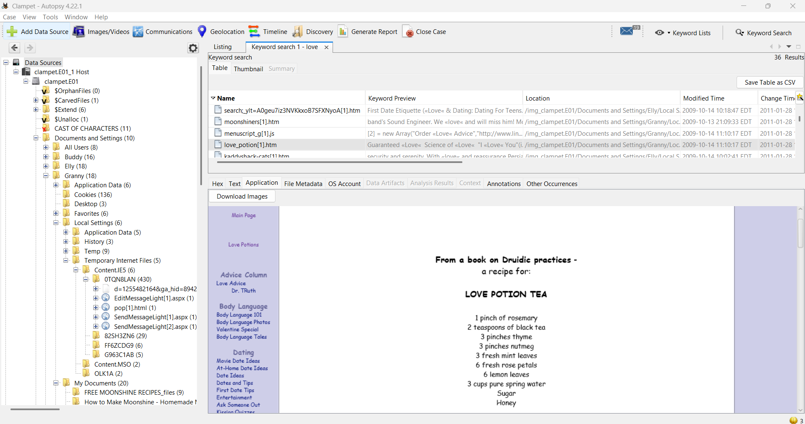

Figure 30 Love potion guide

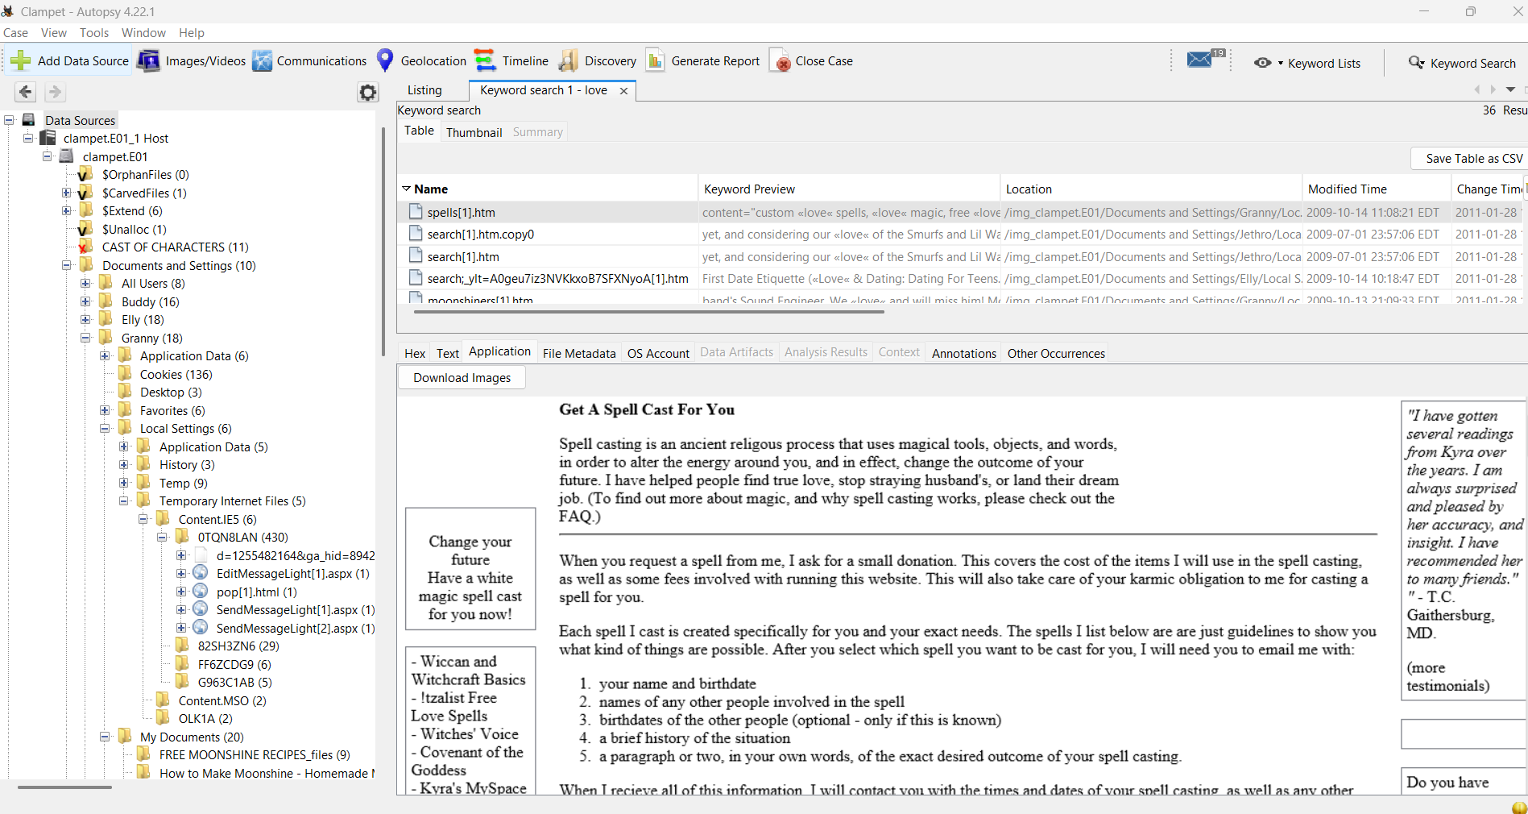

Figure 31 guide on casting spells

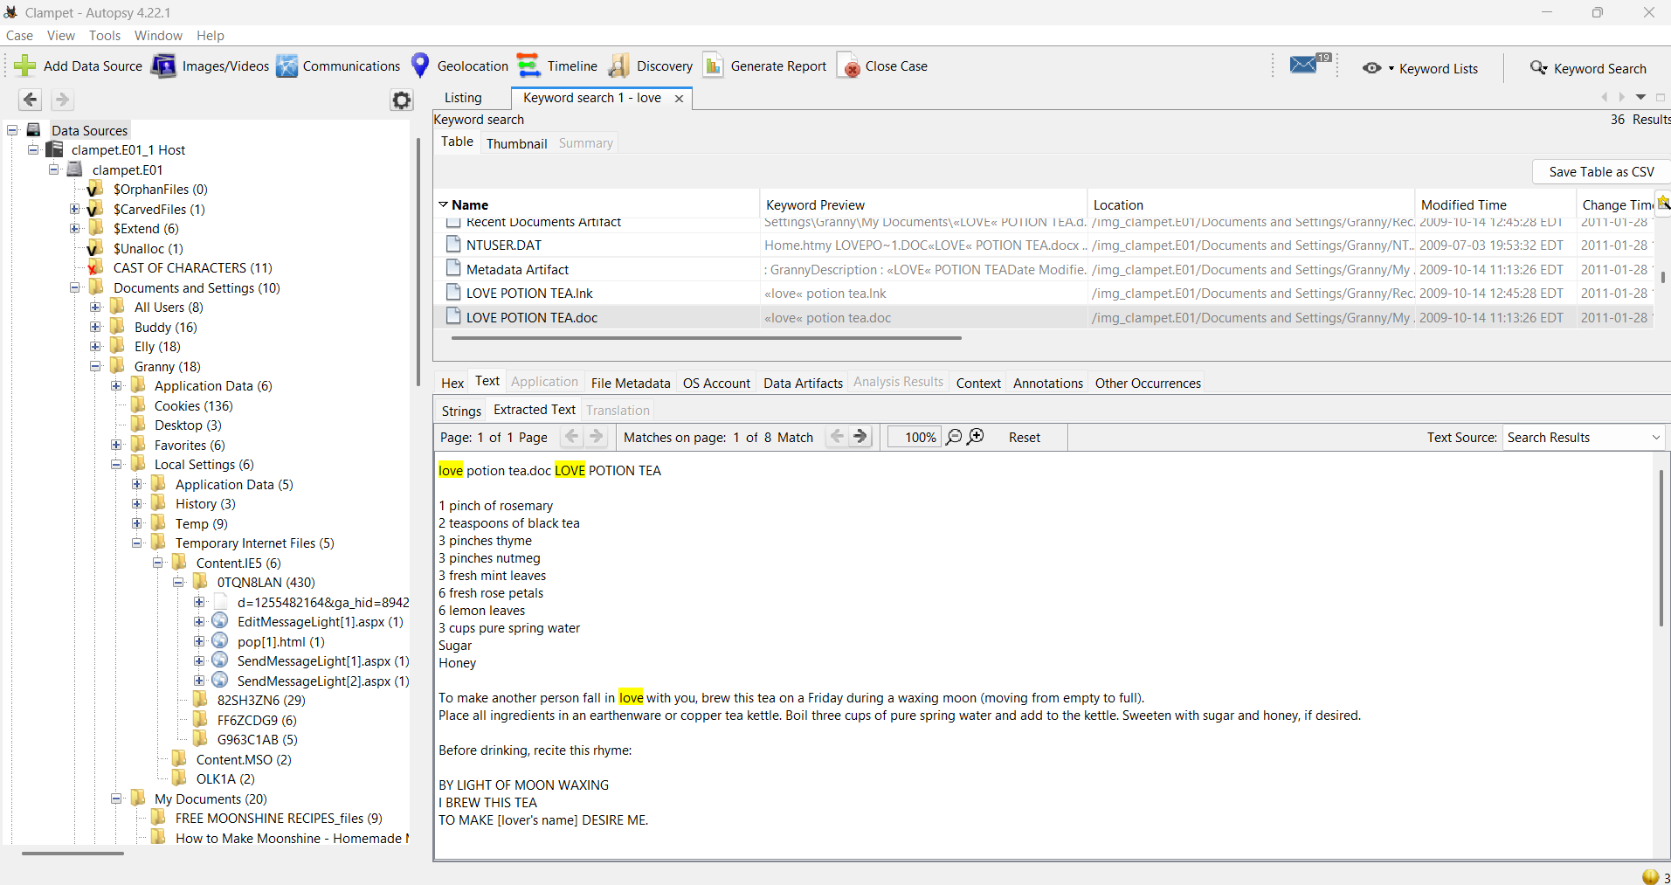

Figure 32 recipe for love potion

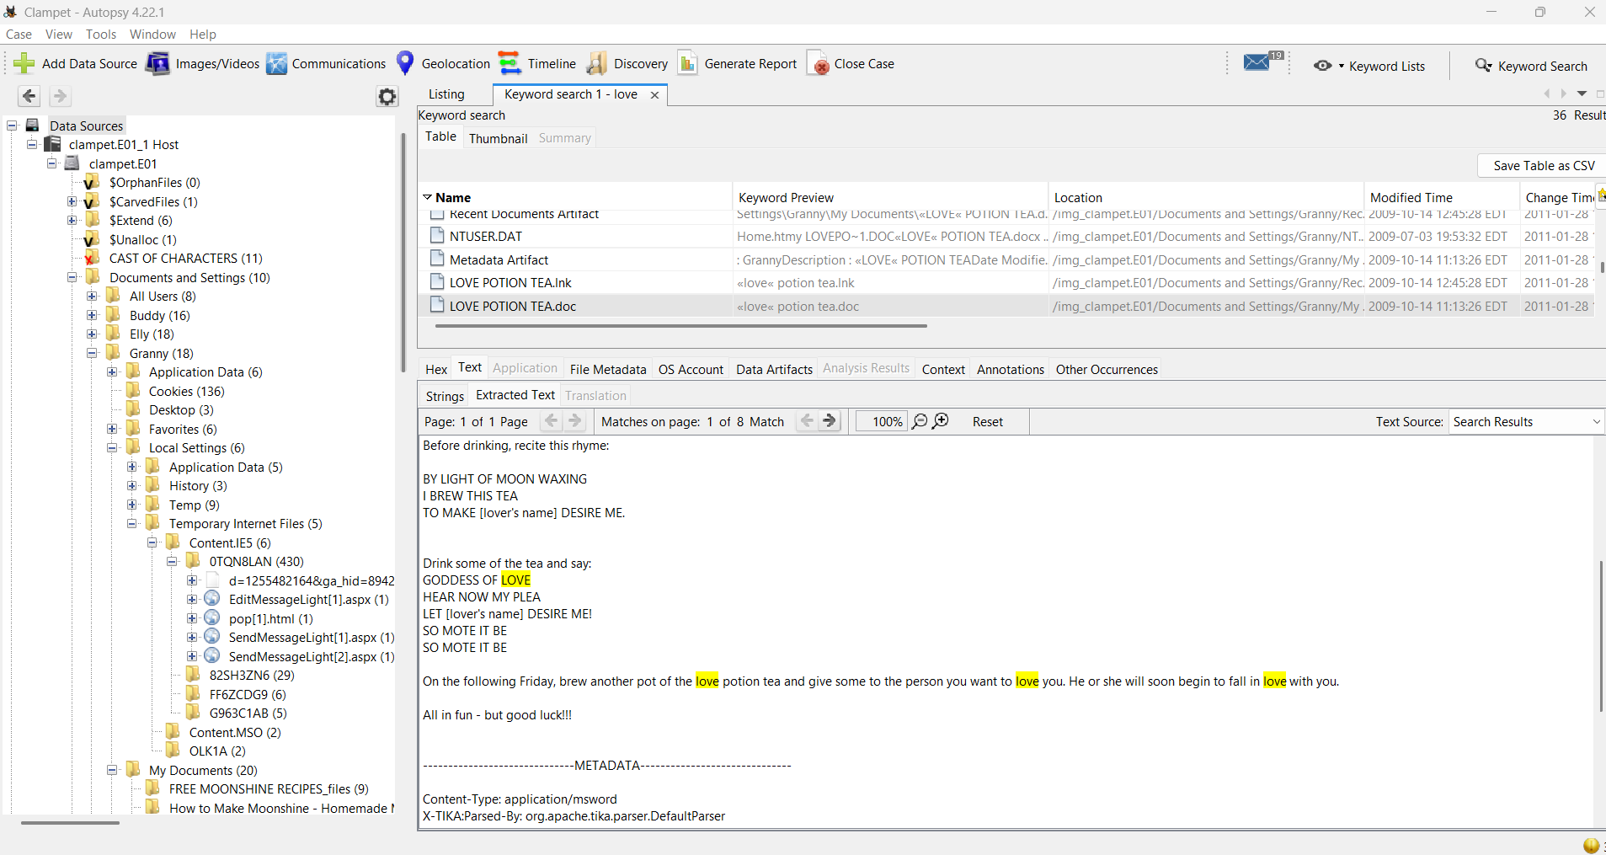

Figure 33 guide on how to use love potion

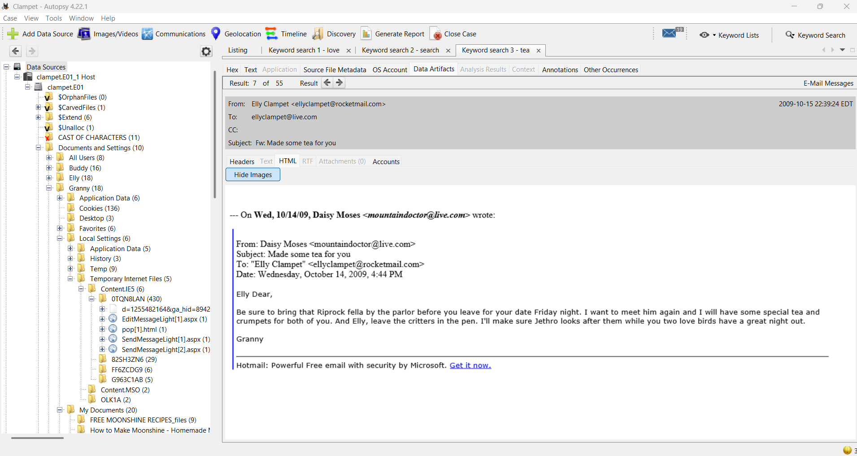

Figure 34 Email from Granny to Elly

## **5. Analysis Summary**

Other user activity analyzed has shown that Jethro has targeted his searches regarding money laundering and moonshine production. Considered together with the instructional documents and images resulting from the Moonshine production, these artifacts may point to a potential relationship between crafting moonshine and subsequently obscuring the financial endpoints. It could be an indication that the user was researching how to sell moonshine and mask the source of funds from the sale, rather than independent or unrelated research.

Several artifacts, such as suspicious search queries, explicit instructional documents on money laundering, images associated with making illegal moonshine, and recovered deleted files, combine to suggest an awareness and an interest in illegal activity. The presence of removable USB storage devices raises several questions about data exfiltration.

Browser history, document times of access, and deleted files show connections that imply an intention to research, review documents, and then delete information. The actions and practices portrayed here do not imply accident but instead indicate deliberate activity.

## **6. Conclusion**

The forensic analysis of Clampet.E01 uncovered significant indications of suspicious and possibly criminal behavior attributed to the primary user account jethro. Key findings include instructional material related to money laundering, recovered deleted files referencing criminal activity, and corroborating search and image artifacts.

The evidence is strong, as several types of artifacts consistently point to the same timeline. The behavior, based on findings, seems to be intentional rather than incidental. For complete disclosure of activity and any potential subjects involved, it is recommended that further inquiry be made into associated persons, email contacts, and USB media users.